Da Silva Academy
Information
2023

welcome

Mission and Vision Statement
“Mission”

We, the Community of Da Silva Academy School, strive to provide equal educational opportunities for children, irrespective of race or creed. We endeavour to create an atmosphere of understanding and dedicate ourselves to the full development of the child. We commit ourselves to a broad and relevant curriculum so that each child can develop emotionally, spiritually, physically and academically, thus enabling him/her to acquire a good self-image. We will create situations in which the children will make choices and accept responsibility for them. We will further staff development both professionally and personally. In pursuing this mission, we strive to promote a feeling of pride in the school and encourage pupil/parent involvement in all areas, through constant interaction.

“Vision”
Be Proud

Parents Introductory Agenda

Dear parents

Welcome to Da Silva Academy Combined School.
We hope to have a good relationship with all of you and may the year 2023 be a great success.

Please note the opening dates for 2023

- Crèche (Grade RR)- Grade 3 and Grade 8- Wednesday 11 January 2023

- Grade 4-7 and Grade 9, Thursday 12 January 2023

School office will be open Monday 09 January 2023, 07:00am to 12:00pm STRICTLY,
for payments for the whole school.

IMPORTANT

Letters have a reply slip attached and others need to be signed giving permission for different reasons. Reply slips and signed forms to please be sent back to school ASAP.

*Please read through all letters and documents CAREFULLY*

2023 SGB and Staff
School Governing Body
The following members are part of Da Silva Academy’s School Governing body
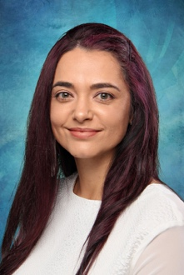
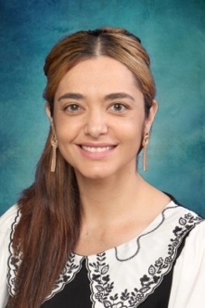

Mrs M. Da Silva
Director
Mr T. Da Silva
Chairperson

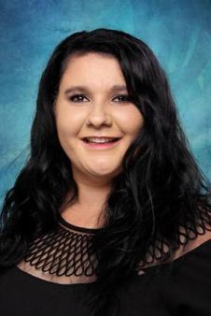
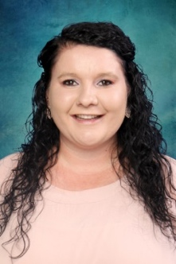

Mrs T. Hautmann
Principal

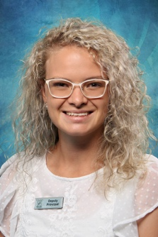

Mrs Blignaut
Deputy Principal

Foundation Phase Departmental Heads
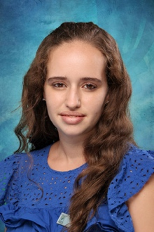
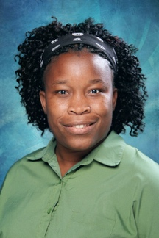
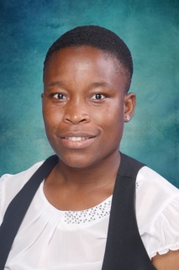

Mrs N. Govender
Miss A. Coetzee
Mrs J. Pereira
Miss B. Novela
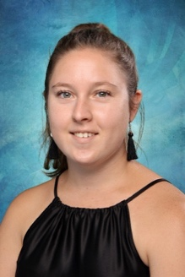

Miss N. Klopper

Intermediate Phase Departmental Heads
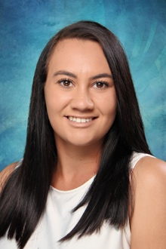
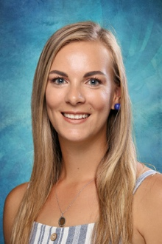

Ms R. Van der Walt
Mrs R. Jankie
Miss V. Saayman
Mrs D. Van Wyk

Head of Sports
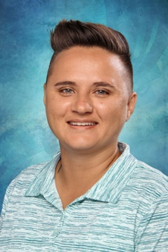
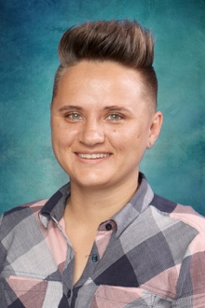

Mrs C. Grobbelaar

Staff Members

Pre - Primary
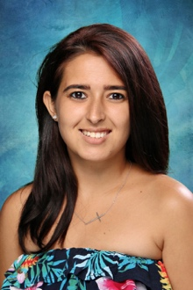
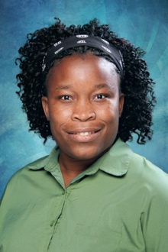
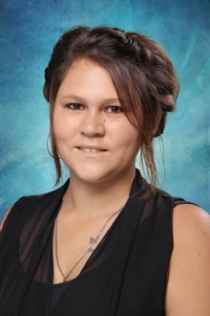

Mrs A. Teixeira
Grade RB
Miss B. Novela
Grade RA
Mrs T. Naude
Creche/ Grade RR

Staff Members

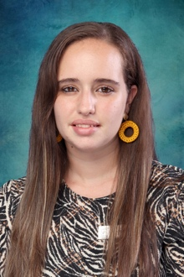
Primary
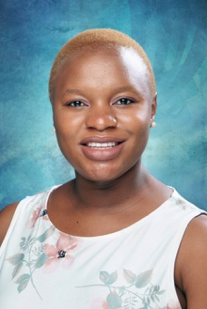

Mrs T. Matlou
Grade 1C
Mrs N. Govender
Grade 1B
Mrs J. Pereira
Grade 1A

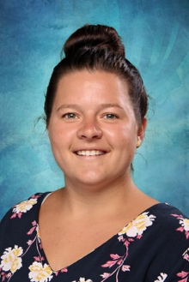
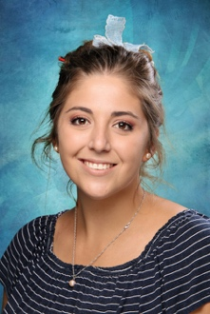

Mrs C.Van Der Merwe
Grade 2A
Miss Z. Klopper
Grade 2B
Miss S. Viljoen
Grade 2C

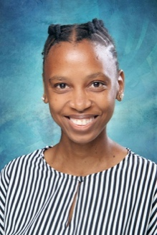

Miss N. Klopper
Grade 3B
Miss K. Phasha
Grade 3A
Miss A. Coetzee
Grade 3C

Staff Members
Intermediate Phase
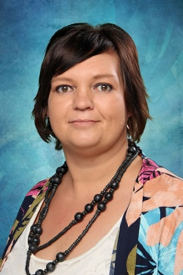
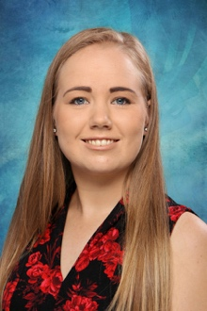
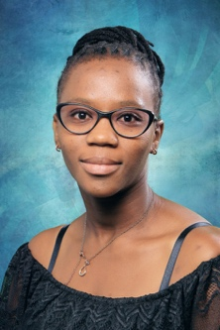
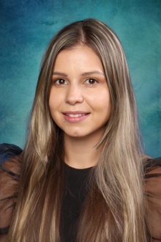

Mrs R. Jankie
Mrs S. Visser
Miss M. Van Biljon

Mrs P. Molahlehi

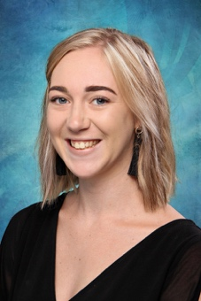

Mrs Van der Walt
Miss Mulenga
Miss Diphoko
Miss C. Van Lelyveld

Mrs J. Beeby

Staff Members
Senior Phase

Miss V. Saayman
Miss R. Van der Walt
Mrs D. Van Wyk

Miss Potelo
Mrs Rautenbach
Miss Mtshali
Miss Du Plessis

Mrs Roos
Computers

Ms W.Van Wyk

School Times
Grade 00 (4-5 class)- Breakfast will be 08:00am. Class will commence after breakfast. Half day learners need to be picked up at 13:00 and full day children to be picked up by 16:00.
Foundation Phase (Grade 1- Grade 2)- School Day will start at 07:15am and will end at 13:00PM. Half Day learners to be picked up at 13:00pm and aftercare learners to be picked up by 16:00.
Grade 3- School day starts at 07:15 and ends at 13:00
Intermediate Phase (Grade 4- Grade 6)- School Day will start at 07:15 and will end at 13:30. Half Day learners to be picked up 13:30 and aftercare learners by 16:00pm.
Senior Phase (Grade 7 ONLY)- School Day will start at 07:15 and will end at 14:00. Half day learners to be picked up 13:30 and aftercare learners by 16:00pm.
Senior Phase (Grade 8 and 9)- School Day will start at 07:15 and will end at 14:00. Half day learners to be picked up 14:00 and aftercare learners by 16:00pm.
A fine of R350 will be added to the account if learners are picked up late.
Office Hours
Monday- Thursday: 07:00am-15:00pm
Fridays: 07:00am- 13:00pm
Lunch
Learners are encouraged to pack healthy lunch boxes. Tuckshop is available at school. Please send learners with proper plastic bottles, NO GLASS, to stay hydrated especially in summer.
Aftercare
Da Silva Academy Combined school offers aftercare for the learners where teachers will assist the learners with their homework. Snack will be provided for the learners in the afternoon. We encourage parents to please go through the homework with the learners and to read with their child every day.

Intervention
Intervention classes are also available for learners (Grade R-7 ONLY) that may be struggling in certain areas of learning. Teachers will focus on the specific area to help the learner improve.
Cost: R 550pm - 14:00 - 15:00/15:30
Grade 8 and 9 learners are to contact outside/private tutors when requested by educators to get extra /intervention classes.
Drop off & Collection Gates
- Grade RR (Creche), Grade R, Grade 1 and Grade 2: Bethlehem Drive Gate
- Grade 7-9: Boshoff Street Gate
- Grade 3-6: Klopper Street Gate

Menu Available at the Tuckshop
Food
Egg, Cheese and Tomato Roll/Toast – R35
Chicken Mayo Roll/Toast – R30
Hotdog Roll - R25
Cheese and Egg Roll – R30
Egg, Ham, Cheese and Tomatoe Roll/toast- R40
Drinks
Water – R10
Tropica - R10
Zoom Juice - R5
Orders are to please be placed in the morning by 07:30am to ensure food is ready by first break.
School Fees and Event Fees
School Fees:
As stated in the Financial Policy/ Payment contract signed by parents on the application form, school fees need to be paid by the 3rd of every month, for eg: January school fee is to be paid by 3 January 2023. Failing to comply with the contract will result in learner/s losing their space at Da Silva Academy Combined School. School fees are to be paid over 12 months of the year (January-December). We are an Independent school and depend solely on the school fees to operate as a school, upgrade and make improvements to our establishment. No arrangements will be accepted due to parents not keeping to the agreements.

Event Fee:
This fee covers all Events that happen at school and when learners go on a trip. Each Grade will have 3 outings during the year, please go through the 2023 Agenda to see all important dates for 2023 as the outing dates have already been added. The fee also covers all fun activities that take place at school such as the Valentines Fun Day, Casual/Splash Day, etc.

Communication from School to Parents

Letters:
Letters for extra murals and other matters such as; clinic coming to the school, fundraising events, concert etc. is the only letters that will be sent home. Therefore, we encourage parents to please download the school’s app to always be up to date with what is happening at school.

WhatsApp Groups:
Each Grade will have a WhatsApp group where daily/weekly reminders will be sent to parents. Only staff members of Da Silva Academy will be able to communicate on this platform. If parents need to communicate with the school, it is to be done strictly via email or personally only if an appointment has been made.

Email:
Emails will also be used to communicate to parents. Parents are encouraged to please ensure that their email address is always up to date in the office to ensure to receive all communications.
*NB! Please Update contact details in the office if there are any changes*

Cultural
Da Silva Academy offers a variety of Cultural activities for the learners to participate in. We give learners a chance to explore in these activities so that they are able to develop in all areas of learning.

The following Cultural activities are offered by the school:

Choir, Public Speaking and Drama

Sports
At Da Silva Academy, we believe that sport plays an important role in education. As well as teaching children, the skills and knowledge required to play the various sports, there are many important, life-long lessons to be learned.
Children learn values such as teamwork, discipline, pride in performance and always giving of their best. These lessons all contribute to the formation of a well-rounded character.
The most important aim of our sports programme is to develop a love of sport and a healthy lifestyle, as this will benefit our pupils for the rest of their lives. The Sports programme forms part of our school curriculum and is included in school fees.
Please note that learners do trials for the different sports and will be chosen for the sport that they excel in. Learners cannot be chosen for every event at the school.
The following sports are offered by the School
Hockey, Soccer, Athletics and Netball

Houses

Da Silva Academy has four teams for the athletics and any other house competition that take place throughout the year. At the inter-house athletics learners, will be competing in the athletics and gain points for their house. During the year, there will be other competitions done at school which will allow the teams to build their points. At the end of the year at Awards Evening the house with the most points will be rewarded with the Spirit Cup.

The Houses are as follows:
- Fire (Red Team)
Captain- Miss van Lelyveld
Team- Mrs Beeby, Miss Saayman, Mrs Pereira, Mrs. Van Wyk, New Educator, Miss Mtshauli, Babra, Thato

- Earth (Green Team)
Captain- Miss Z Klopper
Team- Miss Novela, Mrs Visser, Mrs Jankie, Ms W.Van Wyk, Miss Diphoko, Miss Du Plessis, Khumo, Linidiwe

- Wind (Yellow)
Captain- Mrs Teixeira
Team- Miss N Klopper, Miss Molahlehi, Miss vd Walt, Mrs Govender, Miss Mulenga, Miss Potelo, Mrs Rautenbach, Fezeka, Johanna

- Water (Blue)
Captain- Miss Phasha
Team- Miss Viljoen, Mrs Roos, Miss Van Biljon, Miss Coetzee, Mrs Matlou, Mrs vd Walt, Nandipha, Catherine

2023 Entrants will be allocated into a team and will remain in that team while attending Da Silva Academy. Shirts are available at Professional Schoolwear.
2023 Primary School Uniform Information
Please take note of the following for the school uniform. It will be COMPULSORY for learners to have the correct uniform.
School uniform can be purchased at the following shops:
- Professional Schoolwear, 53 Steen Street
- Babusi, 1A Oliver Tambo Drive
- Bezmans, 55A Von Wielligh
Please make sure learners have the correct school uniform.
They may NOT be wearing any other clothing!
Primary:
Grade R
- Summer
Boys and Girls- Orange golf shirts with black shorts, short black school socks with orange stripes and black school shoes ONLY.
- Winter
Boys and Girls- Da Silva Academy tracksuit with the orange LONG SLEEVE shirts (Can be purchased at school office), black school socks and black school shoes ONLY.
OR

Girls may wear their tunics (NO SHORTER than four fingers above their knee) with black stockings, school jersey (black with school badge on) and school shoes. Learners have to wear a ski pants underneath.
Grade 1-7
- Summer
Boys- White school shirt with the school badge on, school pullover (optional), black short pants, long black school socks with orange stripes and black school shoes ONLY.
Girls- School tunic (NO SHORTER than four fingers above their knee), short black school socks with orange stripes and school shoes ONLY. Learners have to wear a ski pants underneath.

- Winter
Da Silva Academy tracksuit with the orange LONG SLEEVE shirt (Can be purchased at school office), black school socks with orange stripes and black school shoes ONLY.
OR
Boys- White long sleeve shirt with school badge, school jersey with school badge, long black school pants, black school socks with orange stripes and black school shoes.
Girls- Tunics (NO SHORTER than four fingers above the knee) with black stockings, school jersey (black with school badge on) and black school shoes. Learners have to wear a ski pants underneath.
PE Uniform: ONLY TO BE WORN ON PE DAY
Boys- PE shirts with black shorts, short black socks with orange stripes, black or white tekkies.
Girls- PE shirt with black shorts, short black socks with orange stripes and black or white tekkies.
(Please pack an extra pants in for the PE days).

*Only Intermediate Phase (Grade 4-7) wear the ties. Grade 4-Grade 7 wear the orange and black striped tie.
WHOLE SCHOOL: Orange golf shirts and shorts are to be used for sports clothes. Learners will change into their sports clothes after school or before their activity.

*ATTENTION GRADE 7*
Grade 7 learners to please have the blazer which is black with the school badge on the first school day of 2022. The blazer can be purchased by Professional Schoolwear, 53 Steen Street.

2023 High School Uniform Information
Please take note of the following for the school uniform. It will be COMPULSORY for learners to have the correct uniform.
School uniform can be purchased at the following shops:
- Professional Schoolwear, 53 Steen Street
- Babusi, 1A Oliver Tambo Drive
- Bezmans, 55A Von Wielligh
They may NOT be wearing any other clothing!
- All learners:
- The school blazer (black with school logo on pocket)- Throughout the year.
- PE uniform (new skipper for high school) with the school shorts, short school socks with orange stripes and plain black/white tekkies- For PE days.

- Summer
- Boys- White school shirt with the school badge on, school pullover, black short pants, long black school socks with orange stripes on and black school shoes ONLY.
- Girls- School skirt (ski pants underneath and NO SHORTER than 4 fingers above the knee), white school shirt with the school badge on, school bow tie, short black school socks with orange stripes on and school shoes ONLY. Learners are not allowed to wear their long black school pants.

- Winter
- Boys- Blazer, White long sleeve shirt with school badge, school jersey with school badge, long black school pants, black school socks with orange stripes and school shoes.
- Girls- School skirt (ski pants underneath), white school shirt with the school badge on, school bow tie, short black school socks with orange stripes and school shoes ONLY. Learners are allowed to wear their long black school pants.
OR
Blazer, White long sleeve shirt with school badge, school jersey with school badge, long black school pants, black school socks with orange stripes and school shoes.
- Boys and Girls- Tracksuit to ONLY BE WORN on PE days.

Curriculum, Homework and Reports

Foundation Phase Academic Programme
We are using the CAPS Platinum Textbooks as part of our curriculum.

Jolly Phonics
• Children learn the 42 sounds in English
• 60+ sight words
• Fun actions to help memorise sounds
• Fun games and activities for consolidation
• Grammar in Grades 2 and 3 with actions and colour words
• Spelling is code-based

Reading: Letterland
• Characters remain the same through the phase
• Children identify with the characters in the book
• Readers are bright and colourful
• Good repetition of vocabulary at each level
• Group guided and shared reading
• Love for reading encouraged
• Learners taught to read with comprehension
• Each book is a wonderful adventure for the characters

Platinum Maths
• Encourages children to think creatively, logically and independently
• Good step by step progression
• Lovely concrete aids to encourage practical learning
• Fun activities to cover all mathematical concepts
• Love for mathematics instilled in each learner

Intermediate Phase
Academic Programme
Intermediate Phase learners are taught from the CAPS curriculum and do the following subjects:
- English Home Language (Grade 4- Grade 8)
- Afrikaans First Additional Language (Grade 4- Grade 8)
- Mathematics (Grade 4- Grade 8)
- Life Skills (Grade 4- Grade 8)
- Natural Science and Technology (Grade 4-6)
- Social Science (Grade 4- Grade 9)
- Natural Science (Grade 7-9)
- Economic Management Science (Grade 7 - 9 ONLY)
- Technology (Grade 7 - 9 ONLY)
- Creative Arts (Grade 7 - 9 ONLY)

Homework
Grade R- Grade 3: Homework sheets will be put in the homework books every Monday.
Grade 4-9: Learners to have a diary where they will be responsible to record their own homework on a daily basis.
Homework must please be completed every day. After care teachers, may assist with homework but Parents need to sign the homework sheet and check the homework daily. Parent involvement plays an important role in the success of the learner’s school career. Learners need to read EVERYDAY at least for 20 minutes every evening.
Projects and study work (Grade 4-9 learners) are to be completed at home and handed in on the due date. Instructions for projects and breakdowns for tests/examinations (grade 4-9) are given to learners well in advance.
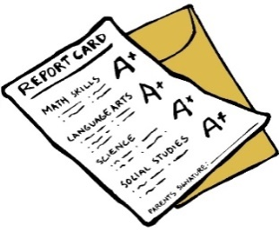
Grade R-3: One week a month there will be no homework as we believe that family time is very important and learners need that time to be children. Learners that attend aftercare will not just be playing in the afternoons for that week, they will focus on the reading and spelling only.

Workbooks
As per the North W4est Department of Education requirement all workbooks (NOT TEXTBOOKS) need to be covered with pink covering. Please ensure to have workbooks covered in pink on the first day of school. On the learners first day of school, they will receive a white paper book cover that is to be pasted on the pink covering on the front of the book. Once it is pasted, then book can be covered with plastic. The pink covering can be purchased at Bhams Stationers. Parents are welcome to come to the school office to confirm the shade of pink.
Reports
There will be four reports during the year.
There will be parents evening every Term after the school holidays. If reports are not collected on parents evening, it is the responsibility of parents to collect their child’s report from the office.

Birthdays
Learners will be allowed to wear Civvies (home clothes) on their Birthday Day at school. If treats will be brought to school, parents are to please send cupcakes instead of cake and are welcome to contact the school office to confirm number of learners in the child’s class.
Important documents
All the documents need to please be read through thoroughly, filled in and signed.

Please send them in the learner’s homework book as the forms need to stay in the office.

