STATIONERY LIST – GRADE R

* PLEASE NOTE THAT THE QUANTITY OF ITEMS ARE FOR 1 TERM. IF ITEMS ARE LOST THEY WILL NEED TO BE REPLACED. IF BOOKS ARE FINISHED EDUCATORS WILL INFORM THE PARENTS IN THE LEARNERS DIARY. PLEASE SEND A 2 LITRE ICECREAM BUCKET TO SCHOOL TO KEEP THE STATIONERY SAFE. *

DESCRIPTION | QUANTITY
A4 192pg HARDCOVER FEINT RULED | 4
A4 192pg HARDCOVER QUAD RULED | 1
A4L 32pg INTERLEAVED TISSUE DRAWING BOOK | 1
JUMBO COLOURING ACTIVITY BOOK | 1
STORY BOOK APPROPRIATE FOR CHILDS AGE | 1
24 / 50 PUZZLE APPROPRIATE FOR CHILDS AGE | 1
A4 FLIP FILE 50 POCKETS | 3
PLASTIC BOOK SLEEVE/BAG/FOLDER WITH ZIP | 2
A4 SLIP ON HARD PLASTIC COVERS FOR LEARNERS  WORKBOOKS AND TEXTBOOKS | 20
TISSUE BOX | 1
REAM OF A4 WHITE PAPER – TYPEK 80 GRAM | 1
CELLOTAPE | 1
SMALL BOX ELASTOPLAST | 1
ABACUS | 1
PENCIL CASE | 1
A4 WHITEBOARD | 1
WHITEBOARD MARKERS | 2
PONAL WOOD GLUE | 1
PRITT GLUE STICK – LARGE | 2
ERASER | 1
STAEDTLER TRADITION 110 PENCILS HB (BOX OF 12) | 1
PLAYDOUGH (DIFFERENT COLOURS) | 1
COUNTING CUBES | 1
PACKET OF WET WIPES | 1
PAINTING APRON | 1
PENCIL CRAYONS – SET OF 12 | 1
RETRACTABLE WAX CRAYONS – SET OF 12 | 2
RULER 30CM | 1 (ONLY IN TERM 4)

STATIONERY LIST – GRADE 1 * PLEASE NOTE THAT THE QUANTITY OF ITEMS ARE FOR 1 TERM. IF
ITEMS ARE LOST THEY WILL NEED TO BE REPLACED. IF BOOKS ARE FINISHED EDUCATORS WILL INFORM
THE PARENTS IN THE LEARNERS DIARY. PLEASE SEND A 2 LITRE ICECREAM BUCKET TO SCHOOL TO KEEP THE STATIONERY SAFE. *
DESCRIPTION QUANTITY
A4 192pg HARDCOVER FEINT RULED 5 A4 192pg HARDCOVER QUAD RULED 1
JUMBO COLOURING ACTIVITY BOOK 1
STORY BOOK APPROPRIATE FOR CHILDS AGE 1 A5 HARDCOVER BOOK FEINT RULED 1
A4 SOFT COVER 96PAGES BOOK FEINT RULED 1

24 / 50 PUZZLE APPROPRIATE FOR CHILDS AGE | 1
A4 FLIP FILE 50 POCKETS | 3
PLASTIC BOOK SLEEVE/BAG/FOLDER WITH ZIP | 1
A4 SLIP ON HARD PLASTIC COVERS FOR LEARNERS  WORKBOOKS AND TEXTBOOKS | 20
TISSUE BOX | 1
REAM OF A4 WHITE PAPER – TYPEK 80 GRAM | 1
SMALL BOX ELASTOPLAST | 1
ABACUS | 1
PENCIL CASE | 1
A4 WHITEBOARD | 1
WHITEBOARD MARKERS | 2
PONAL WOOD GLUE | 1
PRITT GLUE STICK – LARGE | 2
ERASER | 2
STAEDTLER TRADITION 110 PENCILS HB (BOX OF 12) | 1
PENCIL CRAYONS – SET OF 12 | 1
RETRACTABLE WAX CRAYONS – SET OF 12 | 2
RULER 30CM | 1
PENCIL SHARPENER | 2
STUDENT SCISSORS | 1
OIL PASTELS | 1

STATIONERY LIST – GRADE 2 * PLEASE NOTE THAT THE QUANTITY OF ITEMS ARE FOR 1 TERM. IF
ITEMS ARE LOST THEY WILL NEED TO BE REPLACED. IF BOOKS ARE FINISHED EDUCATORS WILL INFORM

THE PARENTS IN THE LEARNERS DIARY. PLEASE SEND A 2 LITRE ICECREAM BUCKET TO SCHOOL TO KEEP THE STATIONERY SAFE *

DESCRIPTION | QUANTITY
A4 192pg HARDCOVER FEINT RULED | 8
A5 96pg HARD/SOFTCOVER FEINT RULED | 1
A4 192pg HARDCOVER QUAD RULED | 2
EXAM PAD A4 100 SHEETS PUNCHED | 1
STAEDTLER PENCIL HB | 1
STORY BOOK APPROPRIATE FOR CHILDS AGE | 1
A4 FLIP FILE 50 POCKETS | 4
A3 FLIP FILE 50 POCKETS | 1
PLASTIC BOOK SLEEVE/BAG/FOLDER WITH ZIP | 4
A4 SLIP ON HARD PLASTIC COVERS FOR LEARNERS  WORKBOOKS AND TEXTBOOKS | 20
TISSUE BOX | 1
REAM OF A4 WHITE PAPER – TYPEK 80 GRAM | 1
CELLOTAPE | 1
SMALL BOX ELASTOPLAST | 1
COUNTING CUBES | 1
PENCIL CASE | 1
A4 WHITEBOARD | 1
WHITEBOARD MARKERS | 2
PONAL WOOD GLUE | 1
PRITT GLUE STICK – LARGE | 3
ERASER | 1
STAEDTLER TRADITION 110 PENCILS HB (BOX OF 12) | 1
PENCIL CRAYONS – SET OF 12 | 1
RETRACTABLE WAX CRAYONS – SET OF 12 | 2
RULER 30CM | 1
PENCIL SHARPENER | 1
STUDENT SCISSORS | 1
OIL PASTELS | 1

STATIONERY LIST – GRADE 3 * PLEASE NOTE THAT THE QUANTITY OF ITEMS ARE FOR 1 TERM. IF

ITEMS ARE LOST THEY WILL NEED TO BE REPLACED. IF BOOKS ARE FINISHED EDUCATORS WILL INFORM THE PARENTS IN THE LEARNERS DIARY.*

DESCRIPTION | QUANTITY
A4 192pg HARDCOVER FEINT RULED | 7
A4 192pg HARDCOVER QUAD RULED | 2
A5 96pg HARD/SOFT COVER QUAD RULED | 1
A5 96pg HARD/SOFT COVER FEINT RULED | 2
DICTIONARY (1X ENGLISH) (1X AFRIKAANS/ENGLISH) | 1 OF EACH
AIR DRYING MODELLING CLAY | 1
STORY BOOK APPROPRIATE FOR CHILDS AGE | 1
WATER PAINT (PALLET OF 12 COLOURS) | 1
A4 FLIP FILE 50 POCKETS | 3
PLASTIC BOOK SLEEVE/BAG/FOLDER WITH ZIP | 4
A4 SLIP ON HARD PLASTIC COVERS FOR LEARNERS  WORKBOOKS AND TEXTBOOKS | 20
TISSUE BOX | 1
REAM OF A4 WHITE PAPER – TYPEK 80 GRAM | 1
CELLOTAPE | 1
SMALL BOX ELASTOPLAST | 1
PACK OF COLOUR PENS (Term 3) | 1
PENCIL CASE | 1
A4 WHITEBOARD | 1
WHITEBOARD MARKERS | 2
PONAL WOOD GLUE | 1
PRITT GLUE STICK – LARGE | 2
ERASER | 2
STAEDTLER TRADITION 110 PENCILS HB (BOX OF 12) | 2
OIL PASTELS | 1
PENCIL CRAYONS – SET OF 12 | 2
RETRACTABLE WAX CRAYONS – SET OF 12 | 1
RULER 30CM | 1
PENCIL SHARPENER | 1
STUDENT SCISSORS | 1
KHOKI PEN (PACK OF 12) | 1

STATIONERY LIST – GRADE 4 * PLEASE NOTE THAT THE QUANTITY OF ITEMS ARE FOR 1 TERM. IF
ITEMS ARE LOST THEY WILL NEED TO BE REPLACED. IF BOOKS ARE FINISHED EDUCATORS WILL INFORM
THE PARENTS IN THE LEARNERS DIARY.*
 | DESCRIPTION | QUANTITY
 | A4 192pg HARDCOVER FEINT RULED | 7
 | A4 192pg HARDCOVER QUAD RULED | 1
 | A5 96pg HARD/SOFT COVER QUAD RULED | 2
 | A5 96pg HARD/SOFT COVER FEINT RULED | 3
 | DICTIONARY (1X ENGLISH) (1X AFRIKAANS/ENGLISH) | 1 OF EACH
 | EXAMPAD A4 100 SHEETS PUNCHED | 2
 | ATLAS | 1
 | BALLPOINT PEN – BLUE INK | 3
 | A4 FLIP FILE 50 POCKETS | 8
 | PLASTIC BOOK SLEEVE/BAG/FOLDER WITH ZIP | 6
 | A4 SLIP ON HARD PLASTIC COVERS FOR LEARNERS WORKBOOKS  AND TEXTBOOKS | 30
 | TISSUE BOX | 1
 | REAM OF A4 WHITE PAPER – TYPEK 80 GRAM | 1
 | CELLOTAPE | 1
 | SMALL BOX ELASTOPLAST | 1
 | PACK OF COLOUR PENS | 1
 | PENCIL CASE | 1
 | STAEDTLER PENCIL HB /2B/4B/6B/8B | 1 OF EACH
 | PACK OF 4 HIGHLIGHTERS | 1
 | PONAL WOOD GLUE | 1
 | PRITT GLUE STICK – LARGE | 2
 | ERASER | 1
 | STAEDTLER TRADITION 110 PENCILS HB (BOX OF 12) | 1
 | OIL PASTELS | 1
 | PENCIL CRAYONS – SET OF 12 | 1
 | RETRACTABLE WAX CRAYONS – SET OF 12 | 1
 | RULER 30CM | 1
 | PENCIL SHARPENER | 1
 | STUDENT SCISSORS | 1
 | KHOKI PEN (PACK OF 12) | 1
 | EARTHENWARE CLAY | 1
 | AFRIKAANS HANDBOOK AND STUDY GUIDE (YELLOW AND RED) | 1
 | ENGLISH HANDBOOK AND STUDY GUIDE (YELLOW AND RED) | 1

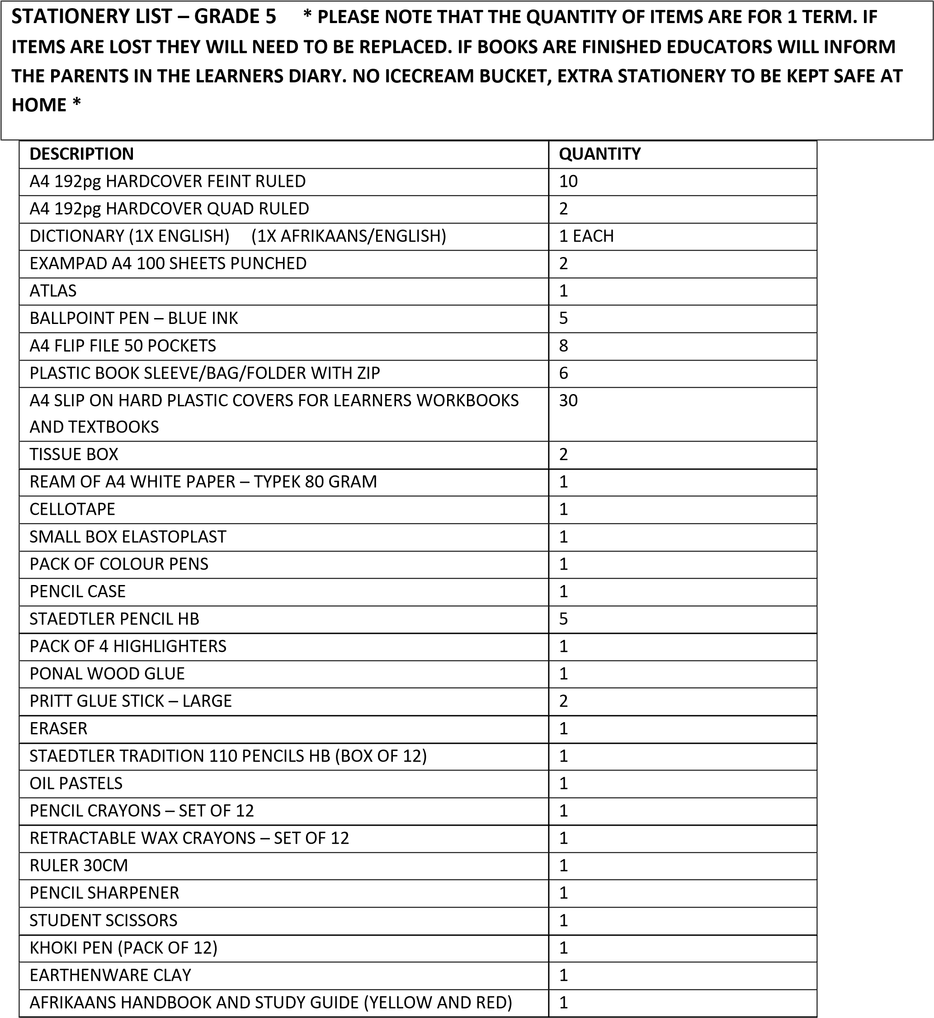
ENGLISH HANDBOOK AND STUDY GUIDE (YELLOW AND RED) | 1
WATER PAINT + PAINT BRUSH | 1 SET

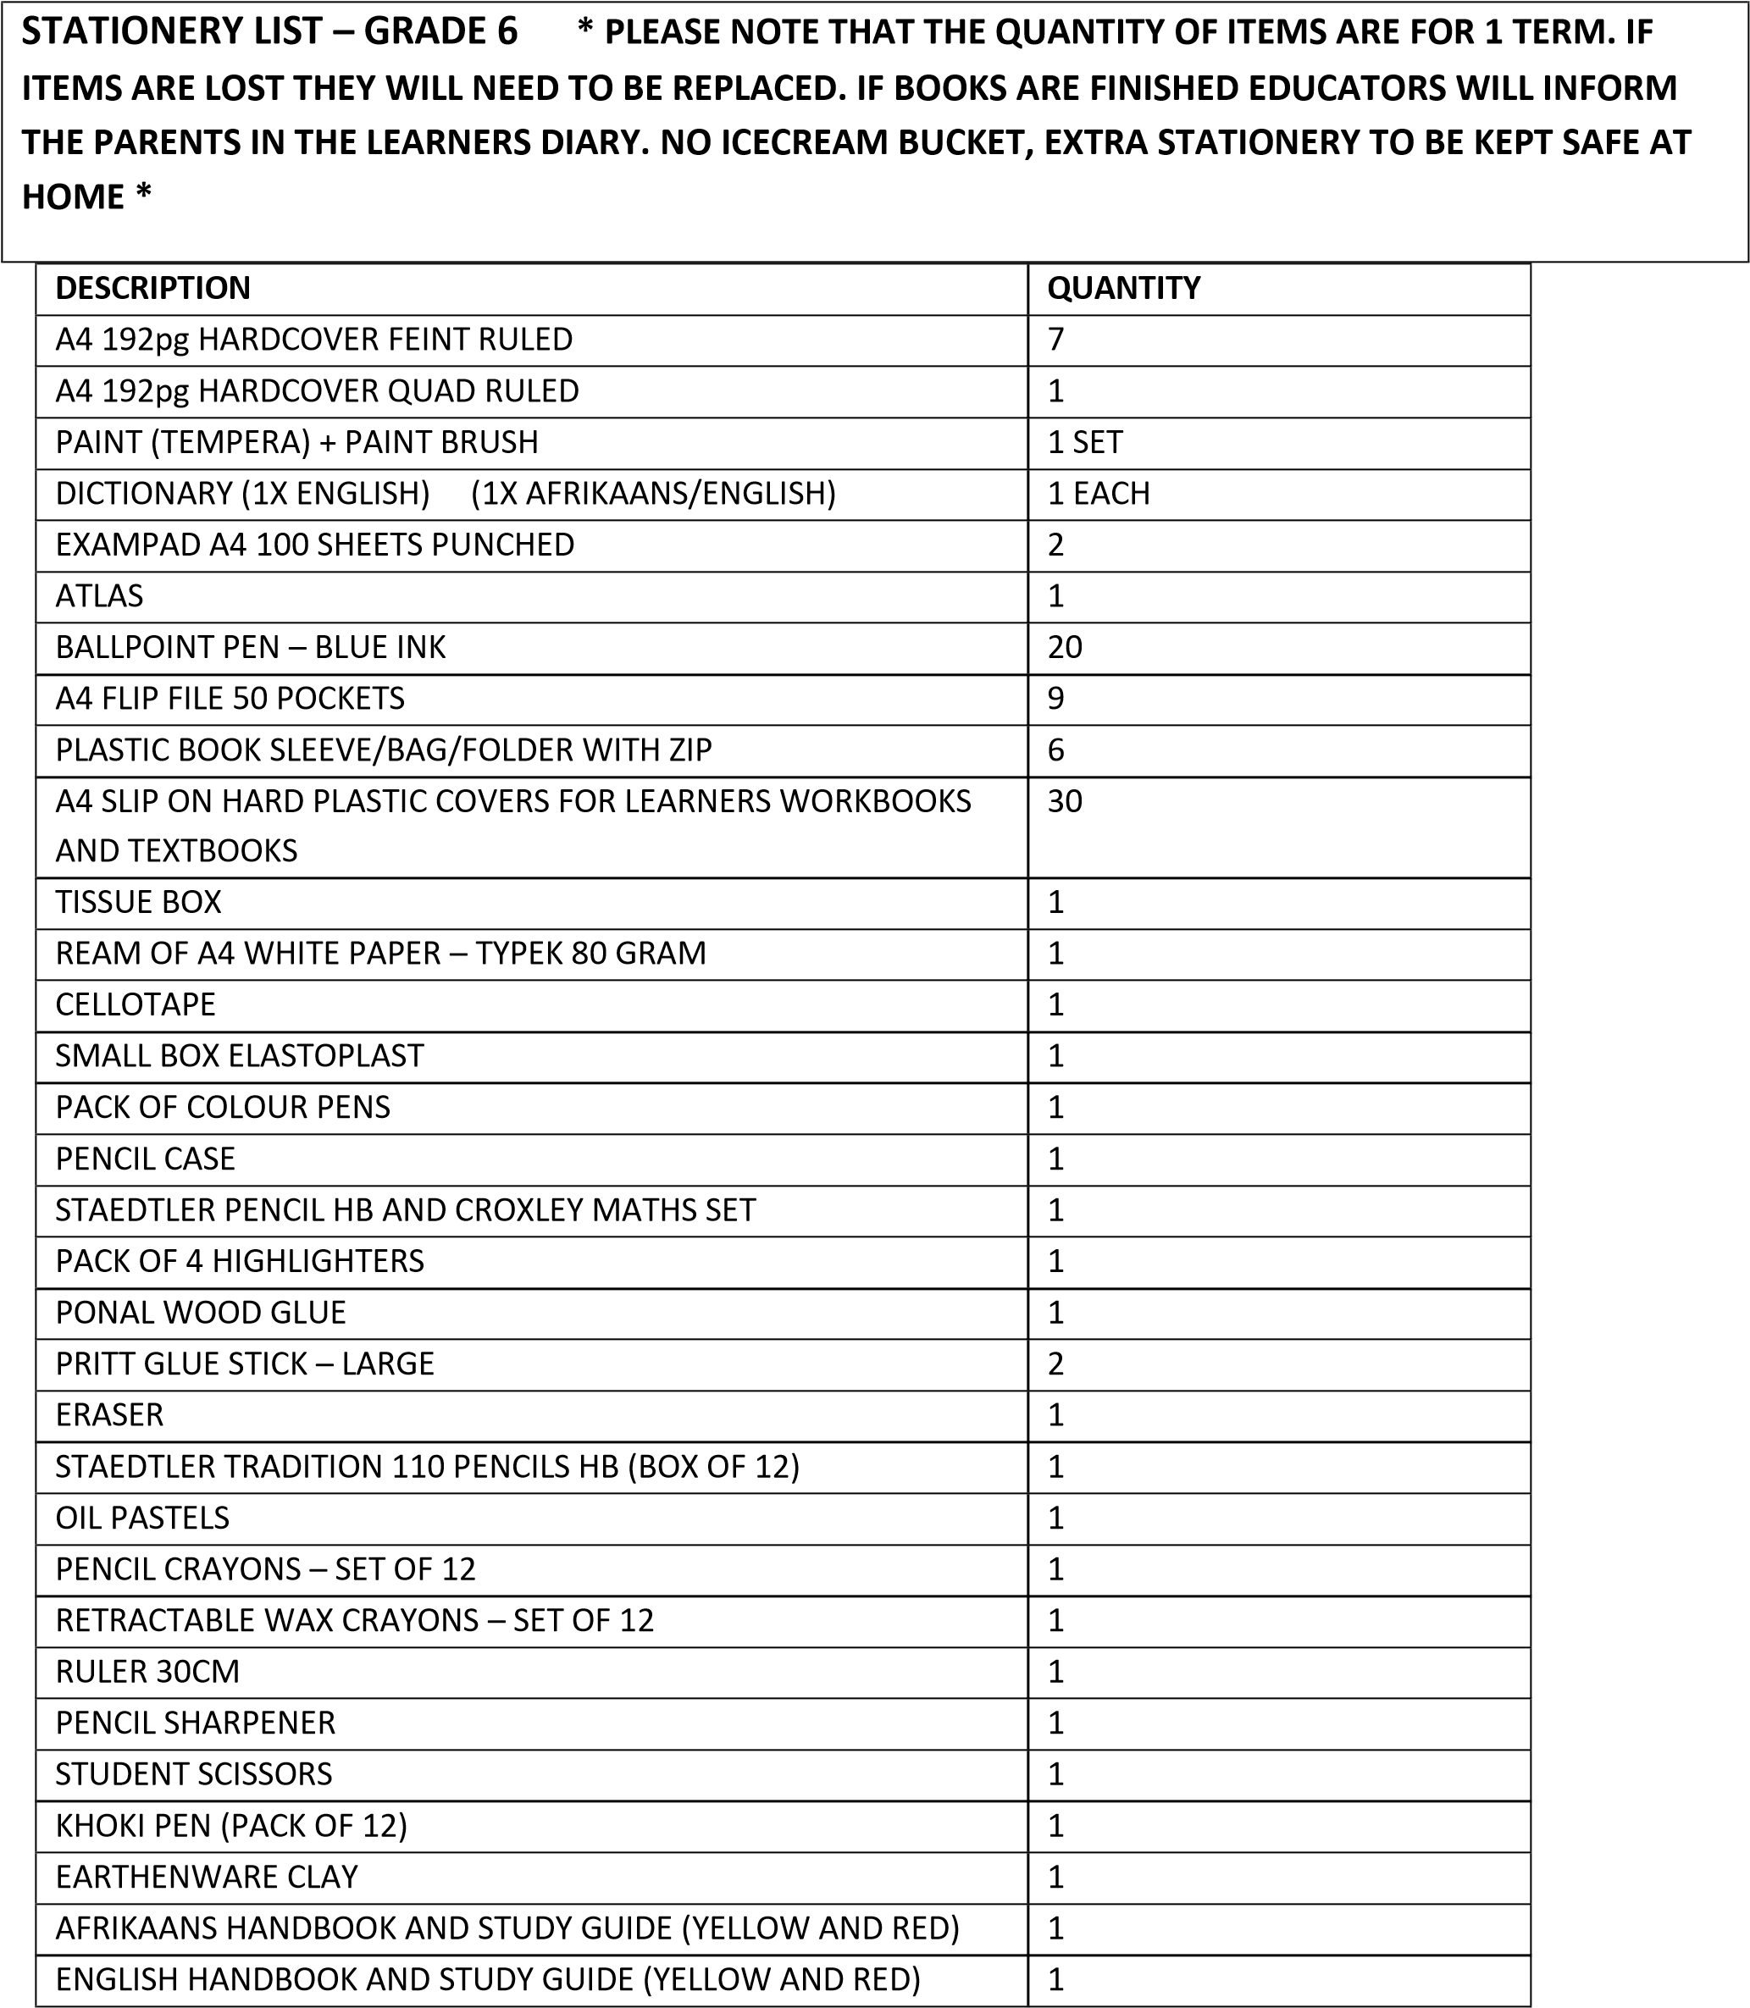
EL231L SHARP BASIC 4 FUNCTION CALCULATOR | 1

STATIONERY LIST – GRADE 7 * PLEASE NOTE THAT THE QUANTITY OF ITEMS ARE FOR 1 TERM. IF
ITEMS ARE LOST THEY WILL NEED TO BE REPLACED. IF BOOKS ARE FINISHED EDUCATORS WILL INFORM

THE PARENTS IN THE LEARNERS DIARY. NO ICECREAM BUCKET, EXTRA STATIONERY TO BE KEPT SAFE AT HOME *

DESCRIPTION | QUANTITY
A4 192pg HARDCOVER FEINT RULED | 9
A4 192pg HARDCOVER QUAD RULED | 1
A5 96pg HARD/SOFT COVER QUAD RULED | 2
DICTIONARY (1X ENGLISH) (1X AFRIKAANS/ENGLISH) | 1 EACH
EXAMPAD A4 100 SHEETS PUNCHED | 2
ATLAS | 1
BALLPOINT PEN – BLUE INK | 5
A4 FLIP FILE 50 POCKETS | 11
PLASTIC BOOK SLEEVE/BAG/FOLDER WITH ZIP | 9
A4 SLIP ON HARD PLASTIC COVERS FOR LEARNERS WORKBOOKS AND  TEXTBOOKS | 30
TISSUE BOX | 1
REAM OF A4 WHITE PAPER – TYPEK 80 GRAM | 2
CELLOTAPE | 1
SMALL BOX ELASTOPLAST | 1
PACK OF COLOUR PENS | 1
PENCIL CASE | 1
STAEDTLER PENCIL HB | 1
PACK OF 4 HIGHLIGHTERS | 1
PONAL WOOD GLUE | 1
PRITT GLUE STICK – LARGE | 2
ERASER | 1
STAEDTLER TRADITION 110 PENCILS HB (BOX OF 12) | 1
OIL PASTELS | 1
PENCIL CRAYONS – SET OF 12 | 1
RETRACTABLE WAX CRAYONS – SET OF 12 | 1
RULER 30CM | 1
PENCIL SHARPENER | 1
STUDENT SCISSORS | 1
KHOKI PEN (PACK OF 12) | 1
EARTHENWARE CLAY | 1
AFRIKAANS HANDBOOK AND STUDY GUIDE (YELLOW AND RED) | 1
ENGLISH HANDBOOK AND STUDY GUIDE (YELLOW AND RED) | 1
EL231L SHARP BASIC 4 FUNCTION CALCULATOR | 1
CROXLEY MATHS SET | 1
ROLFES SKETCH PAD (60 SHEETS) | 1
PAINT (TEMPERA) + PAINT BRUSH | 1 SET
QUOTATION FILES | 2
CHARCOAL PENCIL | 2

